Create And Configure IBM Cloud Service Create A Database in Cloudant DB

|  |  |
| --- | --- |
| **Date** | **05 November 2022** |
| **Team ID** | **PNT2022TMID01040** |
| **Project Name** | **loT Based Safety Gadget For Child Safety Monitoring & Notification** |
| **Maximum Marks** | **4 Marks** |

**AIM**

To create a database in Cloudant DB to store location data

**STEPS**

1. Log in to IBM Cloud with smart interns mail ID and Password.

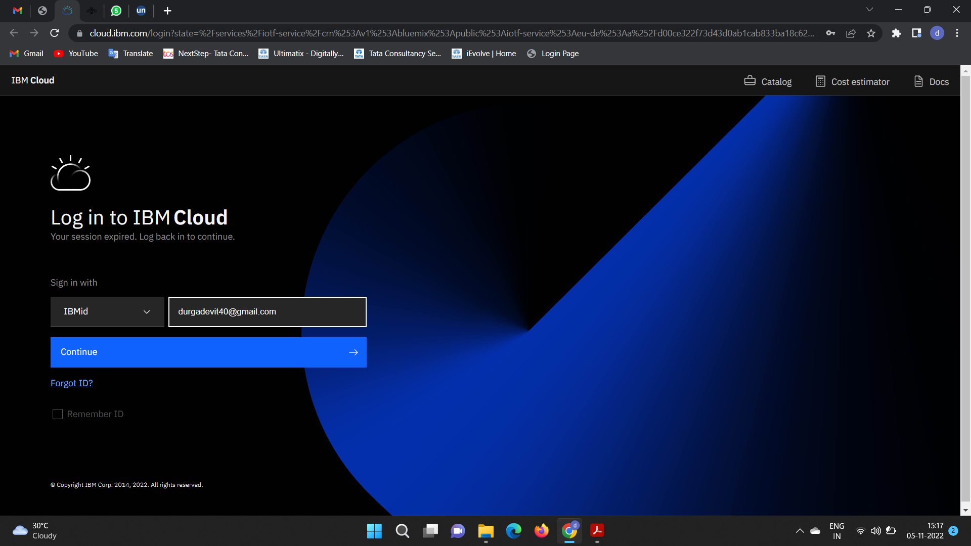

1. 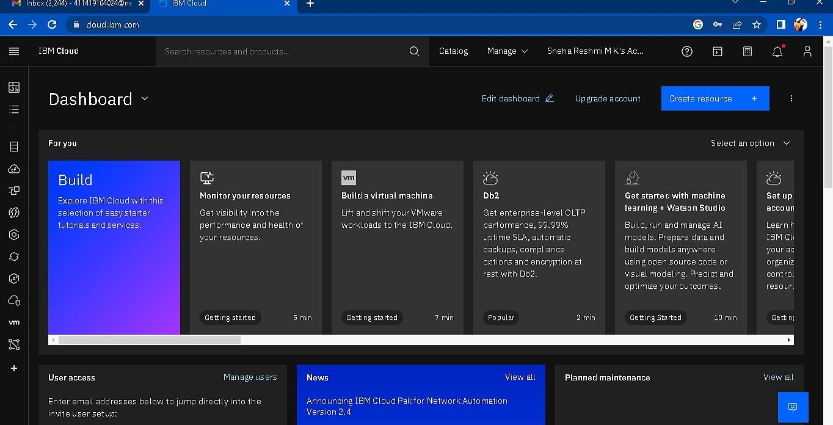Click the “Create Resource +” button
2. 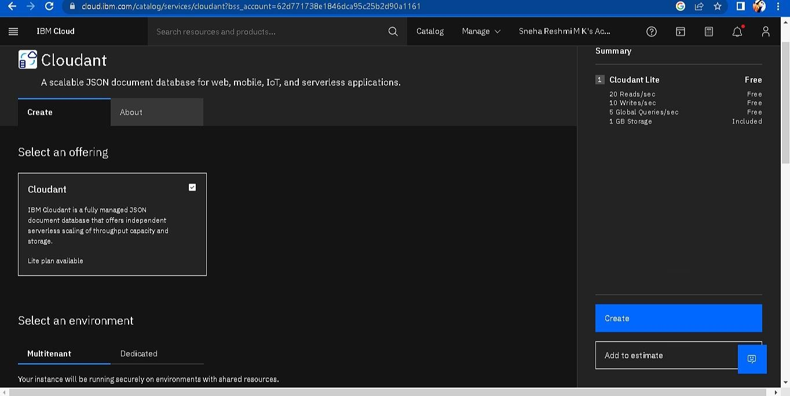Search Cloudant in Catalog then Choose the Lite version

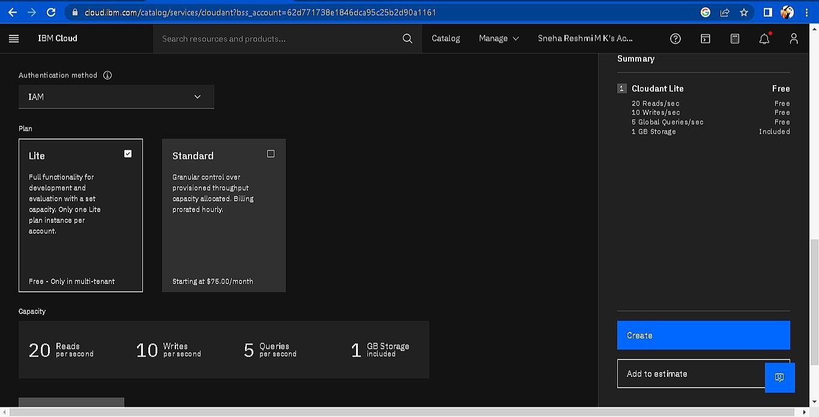

1. 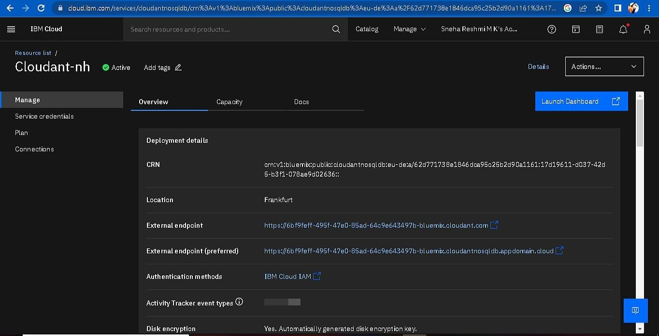The Cloudant database resource created
2. click on the launch dashboard

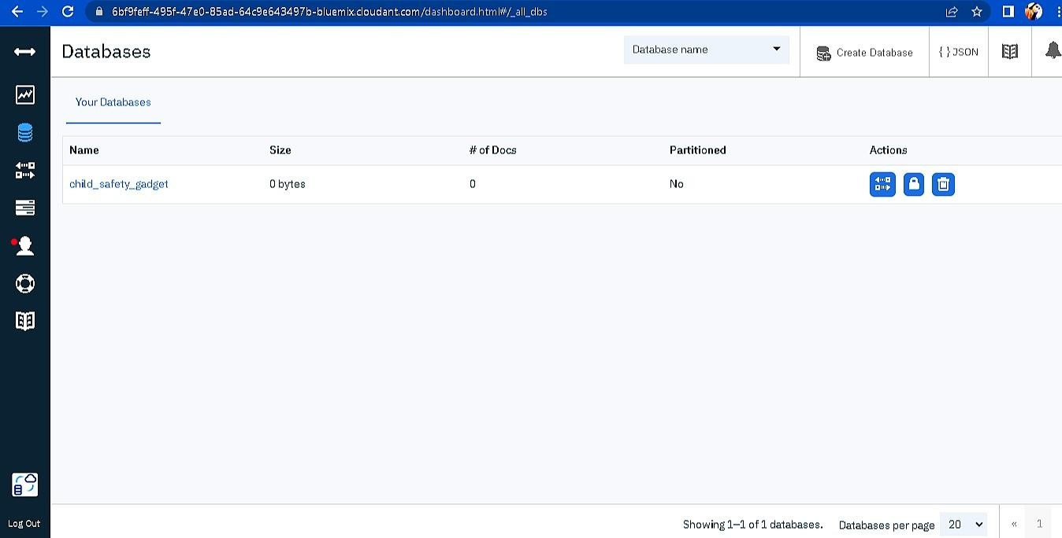

1. Click “Create Database”. Entered “child_safety_device” as the database name and the “Non-partitioned” option.
2. The database “child_safety_device” has been created and it's working Successfully

**RESULT**:

A database to store the location data on the Cloudant database has been created successfully.

# TEAM ID : PNT2022TMID01040

# TEAM LEADER : K. KEERTHANA

# TEAM MEMBER 1 : T. DURGA DEVI

**TEAM MEMBER 2: G. MADHUMITHA**

**TEAM MEMBER 3: M. KAVYA**

# TEAM SIZE 4